Equity Trading System

Installation Guide



© 2003 EGAR Technology Inc. All rights reserved.
This document will help you to install EGAR Equity Trading System.

Installation CD contents
- DataComponents.exe
- ETS.msi
- Backup database file
- Database script files
- DBUpdate.exe
- Documents containing installation guide and user’s guides

Installation from Website:
ftp://data02.egartech.com
Please contact us for login and password

Download the following files and save them on the desktop:
- ETS_Setup_2_1_411.zip
- DB_3_46_121.zip
- Db_scripts.zip
- CreateMaintananceJobs.sql
- Installation guide

Software requirements
Client computer:

- Microsoft Windows NT4 SP 6a /Microsoft Windows 2000 SP3/Microsoft Windows XP SP1

SP 6a is available from
http://www.microsoft.com/ntserver/nts/downloads/recommended/SP6/x86DLType.asp

SP 3 is available from
http://www.microsoft.com/windows2000/downloads/servicepacks/sp3/sp3lang.asp

SP1 for Windows XP is available from http://www.microsoft.com/WindowsXP/pro/downloads/servicepacks/sp1/default.asp

- Data Feed (your choice)
Track Data: http://www.trackdata.com/index.html
Hyperfeed: http://www.hyperfeed.com/
AT Financial: http://www.atattitude.com/ NOTE: AT Financial is not used any more
If you want to use the HyperFeed feed, you need to install Orbit SDK v. 3.3.2.28, which can be downloaded from http://www.pcquote.com
If you want to use the A-T Financial feed, you need to install A-T Attitude, which can be download from http://www.atattitude.com/
Note: The current version of the ETS system allows to install the ISE Price Provider. Please, do not use it, because this functionality is not fully tested now.

- MDAC 2.6 (see below)

Tip: If you don’t have MDAC, you can install it using the DataComponents.exe, which can be found here-> ftp://data02.egartech.com
Please contact us for login and password

Server requirements:

- MS SQL 7.0+SP 2.0 or MS SQL 2000+SP 2.0 (see tip below for trial version)
- SQL Server Agent must be correctly configured

Tip: You can download a trial version of MS SQL from http://www.microsoft.com/sql/evaluation/trial/

Hardware requirements
Server:
- dual-processor Pentium 3 or higher
- RAM 512 MB or more.

Tip: It is advisable to have RAM 1GB and HDD RAID 5.0

Common information

Before installing the ETS system you have to install the database on the server. For more information, see Installing a Database. The ETS system can be installed on any computers (including a server).

The ETS system includes the following parts:
- ETS Market Maker
- ETS Back Office
- Volatility Manager
- Hedger
- Documentation
- Transport Service (Transport Router, Transport Client )
- Price Providers (A-T Financial, HyperFeed, ProTrack, ISE)
- Sage Connector
- First Option Connector
- OConnor Connector
- End of Day Manager
- FIX Gateway
- Version

The ETS Market Maker works only when you have network connection.

Note: If you installed the ETS applications on several computers and want these applications to work as a whole system, you should install the Transport Client on every computer and all Transport Clients have to use the same Transport Router. So the Transport Router can be installed on any one computer. The Transport Router address is entered during installation, but it can be changed manually after installtion. For more information, see System Deployment. If you want to use the OConnor functionality, you can install the FIX Gateway application on any one computer in the system. In case you installed the FIX Gateways on some computers, the only one FIX Gateway can be started at any point of time. The ETS applications installed on different computers in the system should use the same database. The database is selected during installation, but also it can be changed after installation. For more information, see System Deployment.

ETS Database

Installing a Database

You have to install a database on a server before installing the ETS system. Usually a database is delivered as a backup file (file with the extension “bak”), which is restored in MSSQL 7.0 (MSSQL 2000).

Before you begin, find the location of the following:
1) A backup file (.bak either from disk or downloaded from internet) - link to this file will be provided by support team, file is usually put on internet
2) Directory of your MS SQL program and the data folder (Example c:\mssql\data)

To install the new database from a backup file:

- Open MS SQL -> Enterprise Manager and connect to your server.
Drill down in the tree (left hand side) to where you see a folder named databases under your server.
If you have a database already created then skip to step 2.
If you need to create a database then highlight the database folder and go to the action pull down menu at top, select a new database and name it ETS.
- Highlight the ETS database and go to Action-> All Tasks->Restore Database.
- On the next screen select from device: the hit the select device button
- Then you need to add a device: this is where you select your BAK file and select OK.
- Select OK on the choose restore device screen.
- On the restore database screen you must choose the Options tab and do steps 7 through 9.
- Select “Force restore over existing database”
- Replace “Move to Physical file name” columns to the directory you have already selected, where the MS SQL data folder resides on your server. Only changing directory up to but not including the data folder. Leaving the data folder and the file name the same.
- Select OK: you should see a notice that database was successfully restored.
- You should also install support jobs for the database. For more information, see DB support.

Updating the database

You need to update your database, when we release a new version and you have already installed ETS. Database version may change since your last installing ETS and to keep all your data available in new ETS, you have run upgrade scripts.

To update the database:
- Download and extract (to some local folder) the sql scripts from the archive db_scripts.zip file.
- Run the Query Analizer program and execute all scripts that are in this file.

Note: To avoid receiving of error messages & have an ability to modify the objects, you must use the "sa" login when you run DBUpdate.exe utility.

Note: Every sql patches execution changes a database version, which is stored in the DataInfo table. Please don’t change the values in this table manually.

Note: For every update keep the scripts in the separate directory.

To check the database version:
Go to Start->Programs->ETS->Version
or run Check_DB_Ver.sgl in the Query Analyzer. The Check_DB_Ver.sql can be found at http://support.egartech.com/ets/ETS/First%20Install/

DB Support
The database support must be realized by the db administrator. Administrator can use the specially created script CreateMaintananceJobs.sql. You can take this script here: ftp://data02.egartech.com. Please contact us for login and password.
To run the script:
- Run the SQL Query Analyzer.
- Select the destination ETS database.
- Execute the CreateMaintananceJobs.sql script.

The script creates two jobs: DBCleanup and Speed operating with DB.

The DB Cleanup (Database name) job cleans the database (it delete expired options and all data marked as deleted). By default the job is automatically started once a month (at the first Sunday at 00:00).

The Speed operating with DB (Database name) job execution allows to increase the speed of working with the database. By default it is automatically started each Sunday at 4:00AM.

Note: The jobs work only when the SQL Server Agent is started. The "SQL SERVER AGENT" must be started before the CreateMaintananceJobs.sql script execution. You should markup "SQL SERVER AGENT" as 'Auto-Start Service when OS starts' to provide execution of all scheduled jobs at this server.

Note: The CreateMaintananceJobs.sql script allows to organize automatic database support for only one database on the server.

We strongly recommend you to
- create a database backup before updating it.
- ensure the destination database is correctly assigned.
- execute sql patches in a single-user mode or when a number of users addressed to the database is minimal.
- launch scripts using an account with Administrator privileges.
- save the results of SQL patches execution in a standard sql report file ([Filename].rpt) if any errors appear.
- restart SQL Server service after scripts execution.

To save the results of SQL patches execution:
1. Click the results pane
2. Go to File->Save as.

Backup database

To Backup the database:

1. Open MS SQL -> Enterprise Manager and connect to your server.
Drill down in the tree (left hand side) to where the appropriate database is placed on the server.
2. Highlight the ETS database and go to Action-> All Tasks->Backup Database.
3. Then you need to add a destination file, i.e. the file where you will do backup and select OK.
4. Select OK: you should see a notice that backup operation was successfully completed

How to install the ETS application

Note: You must close all ETS applications before reinstalling ETS.

To close the Router Server:
- Right-click on the icon on the status area.
- Select the Stop Router Server command from the drop-down menu.
- Right-click on icon on the status area.
- Select the Exit option from the drop-down menu.

To close the Transport Service:
    - Right-click on the ball on the status area.
    - Select the Stop Transport Service command from the drop-down menu.
    - Right-click on the ball on the status area.
    - Select the Exit option from the drop-down menu.

To close ETS Market Maker, Back Office, Hedger:
go to File->Menu , and select the Exit option.

Tip: The Router Server should be installed on the ONE computer in the network. You can install Router Server on the some computers in the network, but the only one Router Server must be active.

Note: If the following message appears during installation you have to install Microsoft Windows Installer 2.0.

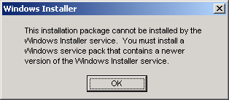

To install MWI 2.0,
go to http://www.microsoft.com/downloads/release.asp?releaseid=32832&NewList=1

To install the ETS system:
- Log in using an account with Administrator privileges.

- If MDAC 2.6 isn’t installed on your computer , install Microsoft Data Access Components using the DateComponents.exe, which can be found here-> ftp://data02.egartech.com. Please contact us for login and password

- 1) To start an installation process, simply run the ETS.msi file. If you have any problems with installation, do step 3.2 to save installation results in the log file.

2) To start an installation process with saving results in the log file, do the following:

  - Click the Start button, select the Run option from the appeared menu.
  - Enter the following command in the Run window:

msiexec -i <complete path to ets.msi file> -l*v <path to log file>

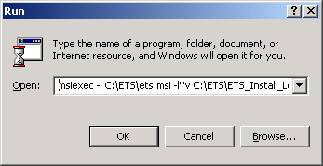

For example, if the ets.msi file lies in the C:\ETS folder, and you want to save the results of installation in the C:\ETS\ETS_Install_Log.txt file, write msiexec -i C:\ETS\ets.msi -l*v C:\ETS\ETS_Install_Log.txt command in the Run window.

- Follow the instructions:

4.1 Click the Next button when it appears.

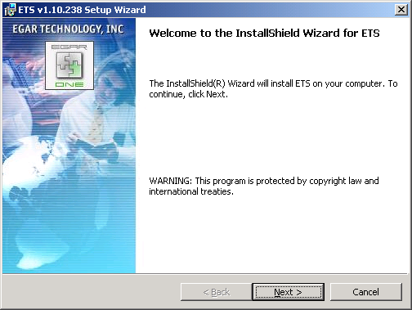

4.2 Enter the Customer information and click Next to proceed.

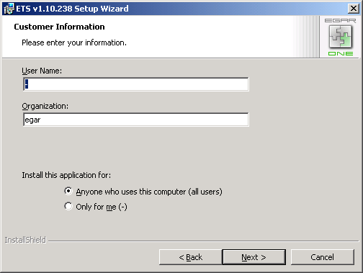

4.3. Select the setup type. There are three possibilities: Market Maker, Back Office and Custom installation.

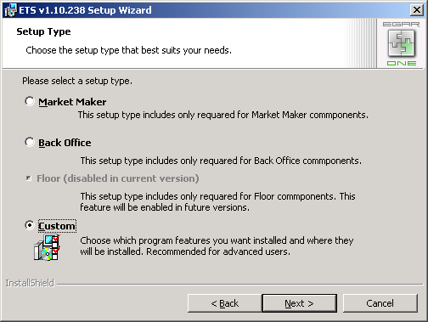

The Custom installation allows you to choose which program features you want to be installed.

Choosing features for Custom installation
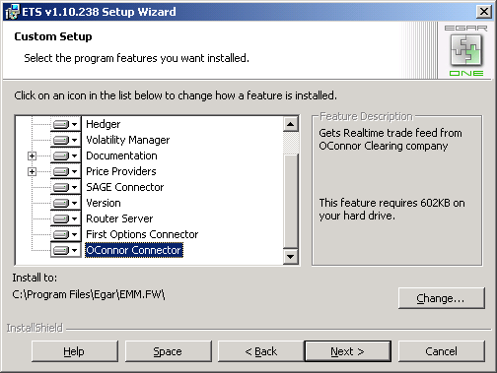

To choose the components you want to be installed:
1. Click an icon near the component in the list
2. Select how a feature will be installed.

4.4. Enter IV server user’s information (login and password).

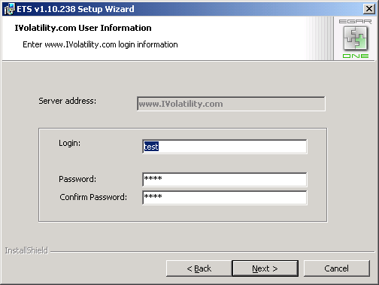

4.5. Select a default price provider from the Default Price Provider drop-down list.

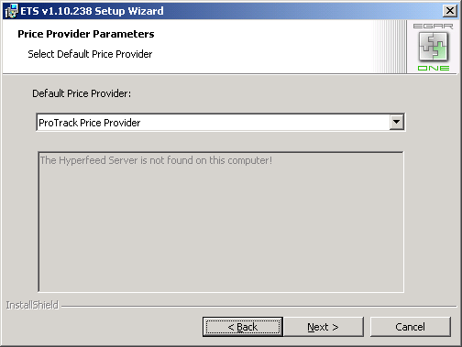

  - If you have selected the SAGE Connector in installation menu, enter SAGE Connector parameters.

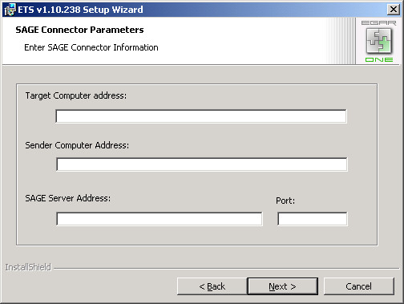

  - If you have selected the First Option Connector in the installation menu, enter the First Option Connector parameters in the appropriate window.

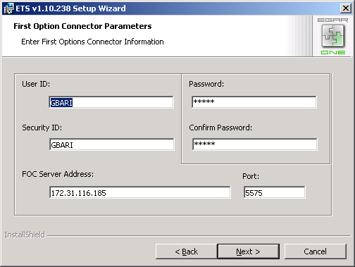

  - If you have selected the OConnor Connector in the installation menu, enter the OConnor Connector parameters.

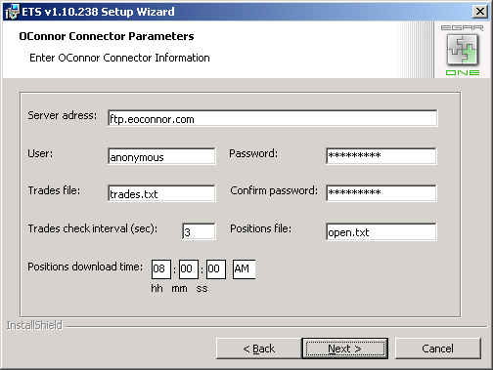

  - Enter the address of the computer on which the Router Server (i.e. Transport Router) has been installed. For trial users that use one computer, the router server address is the name or IP address of this computer (localhost), for users that have a separate server it is the server name. Note, the Router Server also should be installed on this server. The Router Server Address can be changed manually after installtion.

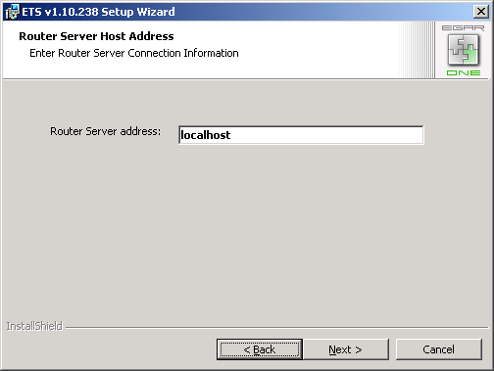

  - Enter the name of the database server and select the database. Click Next. Note, the database settings can be changed after installation.

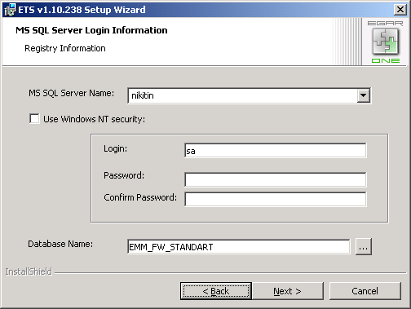

4.11. Click on the Install button.
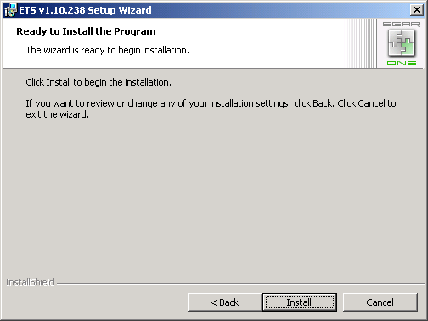

4.12. When the installation process is finished, click the Finish button.

System Deployment
When the ETS system is installed, you can adjust it for your needs and change some settings selected during installation. For example, you can change the database, used by ETS application, the Router Server address etc. For more information, see the System Deployment guide, which can be found in Start->Programs->ETS->Documentation.

